Windows Developer Setup Guide

This document is a setup guide for an Imitation Learning GUI developer using the Windows operating system.

# Clone Git Repository

There are a few options as a Windows user to manage a git repo. The most straight-forward option is to install [GitHub’s desktop client](https://desktop.github.com/).

To download the most recent version from the repo, clone the repo located at <https://github.com/jhomble/electron435.git>.

For assistance with the GitHub desktop client, see the tutorial [here](https://help.github.com/desktop/guides/getting-started/).

# Python

Visit the link [here](https://www.python.org/downloads/windows/) to download and install the latest version of Python.

Once downloaded, add python to your environmental path.

To do this, go to: System Properties -> Environmental Variables

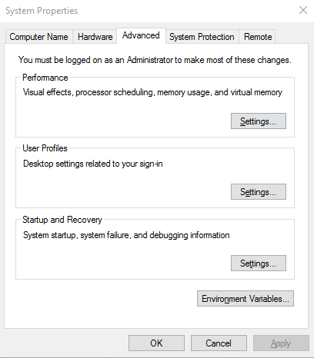

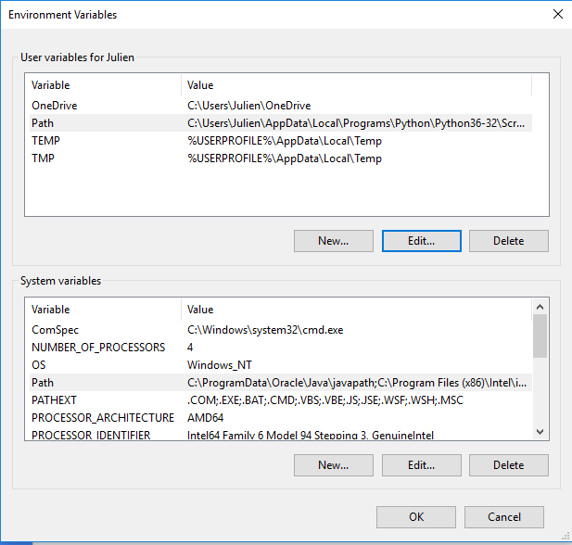

Click on edit, and add the path to where you saved python

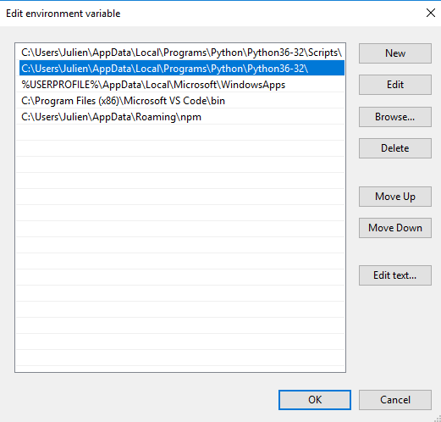

# Node.js & Node Package Manager (npm)

Visit the link [here](https://nodejs.org/en/download/) to download and install the latest version of Node.js and npm. For additional information on npm and its usage in the following steps, see the npm documentation [here](https://docs.npmjs.com/).

# Angular & Electron

Using Windows PowerShell, navigate to the directory in which you cloned the git repo. Then, run the commands npm install angular and npm install electron.

# Setup & Start

Using Windows PowerShell, navigate to the directory in which you cloned the git repo. Then, run the commands npm install and npm start. You will only need to run npm install once. To run the application in the future, you will only need to use the command npm start.